Craft Shop Sales Analysis Report

Name: Noor Fatima
Institution: BS Mathematics, The Women University Multan
Course: Data Analytics & Cloud Basics
Date: 24 October 2026

Objective
To find out which city, product and month brought the most sales for a small online craft shop, so the owner can decide where to focus.

Data
The dataset has 18 orders from July to September. Columns: OrderID, Month, City, Product, Quantity, UnitPrice and Total. The data was created by me for practice. It has no names or phone numbers. Cities: Lahore, Multan, Karachi, Islamabad. Products: Embroidered Shawl, Blue Pottery Vase, Handmade Bag, Khussa.

Analysis
Key numbers:
- Total orders: 18
- Total units sold: 46
- Total sales: Rs 164,600
- Average order value: Rs 9,144
- Highest order: Rs 25,800 (Order 8, Karachi, Embroidered Shawl)
- Lowest order: Rs 1,200

Sales by city:
- Lahore: Rs 55,300 (highest)
- Karachi: Rs 50,000
- Multan: Rs 41,100
- Islamabad: Rs 18,200 (lowest)

Sales by product:
- Embroidered Shawl: Rs 50,800 (30.9%)
- Khussa: Rs 43,000 (26.1%)
- Blue Pottery Vase: Rs 42,700 (25.9%)
- Handmade Bag: Rs 28,100 (17.1%)

Sales by month:
- July: Rs 30,700
- August: Rs 79,400 (highest)
- September: Rs 54,500

Charts:

Sales by City

Lahore and Karachi together make more than half of all sales.

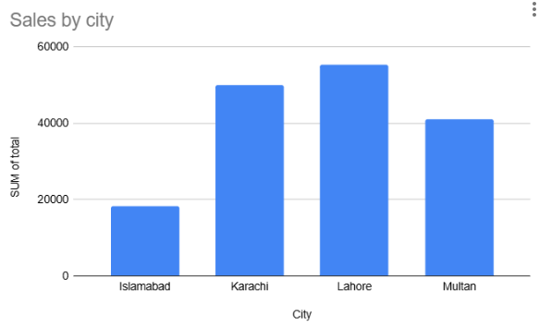

Sales by Product chart

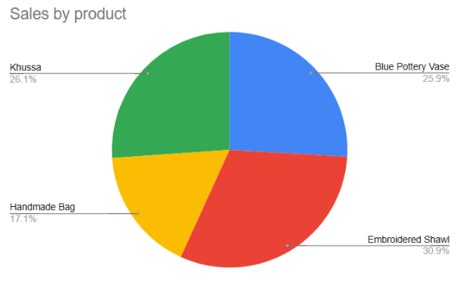

Embroidered Shawl is the best-selling product, while Handmade Bag sells the least.

Sales by Month

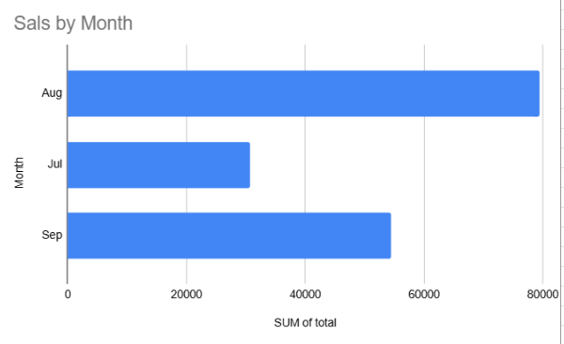

Sales jumped in August, then dropped by about 31% in September.

Recommendation

1. Spend more marketing effort on Lahore and Karachi, because they bring the most sales.
2. Try offers or social media ads in Islamabad, where sales are lowest.
3. Keep extra stock of Embroidered Shawls, as they are the top product.
4. Plan stock early for August, which was the best month, and find out why September fell.
5. Sell Handmade Bags in bundles with other products to increase their sales.

